Syeda Reeha Quasar

14114802719

4C7

Aim

To perform the user’s view analysis for the suggested system: Use case diagram.

Experiment - 4

Software Engineering Lab

# **EXPERIMENT – 4**

## **Aim:**

To perform the user’s view analysis for the suggested system: Use case diagram.

## **Theory:**

The use-case diagram can provide the user’s view for designing of the software product. And it can also be tested by matching up the requirements with the use-cases.

**When to Use:** Use Cases Diagrams

Use cases are used in almost every project. They are helpful in exposing requirements and planning the project. During the initial stage of a project most use cases should be defined, but as the project continues more might become visible.

**Actors:** Are NOT part of the system – they represent anyone or anything that must interact with the system.

* Only input information to the system.
* Only receive information from the system.
* Both input to and receive information from the system.
* Represented in UML as a stickman.

**Use Case**

* A sequence of transactions performed by a system that yields a measurable result of values for a particular actor.
* A use case typically represents a major piece of functionality that is complete from beginning to end. A use case must deliver something of value to an actor

**Use Case Relationships Between actor and use case.**

* Association / Communication.
* Arrow can be in either or both directions; arrow indicates who initiates communication.

**Between use cases (generalization):**

Uses: Where multiple use cases share pieces of same functionality.

## **Performance Instruction:**

1. Identify various processes, use-cases, actors etc. of the system and analyse it.
2. Use processes at various levels and draw use case diagram.

## **Output:**

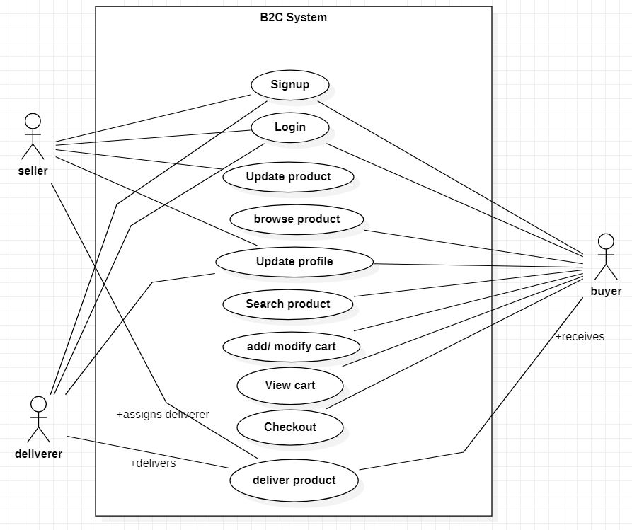



# **Viva Questions**

### **1. Explain use case approach of requirement elicitation?**

### Ans.

This technique combines text and pictures to provide a better understanding of the requirements. The use cases describe the ‘what’, of a system and not ‘how’. Hence, they only give a functional view of the system. The components of the use case design include three major things – Actor, Use cases, use case diagram.

### **2. Explain term: use-case, use-case scenarios, use-case diagrams?**

Ans.

A use case is a written description of how users will perform tasks on your website. It outlines, from a user’s point of view, a system’s behavior as it responds to a request.

A use case scenario is a single path through the use case. unlike a use case which is a step-by-step enumeration of the tasks carried out during a process (with the associated actors), a scenario is much more free-form.

A use case diagram can summarize the details of your system's users (also known as actors) and their interactions with the system.

### **3. What are actors and use cases?**

Ans.

An **actor** in use case modelling specifies a role played by a user or any other system that interacts with the subject. An Actor models a type of role played by an entity that interacts with the subject (e.g., by exchanging signals and data), but which is external to the subject.

A **use case** is a written description of how users will perform tasks on your website.  It outlines, from a user’s point of view, a system’s behaviour as it responds to a request.

### **4. Explain guidelines that should be kept in mind while creating use cases?**

Ans.

Consider the following:

* Single statement per line
* Always have a subject – “User” or “System”
* Be concise – remember, use cases are not end requirements – you should be demonstrating the interaction between the system and user, but not detailed specifications
* Use an active voice

### **5. Name the person who invented use case approach?**

Ans.

Ivar Jacobson first formulated textual and visual modelling techniques for specifying use cases.